**Design a Flange coupling in Solid works**

**Objective:**

To design a Flange coupling in Solid Works and create its animation.

**Introduction**

**What are Couplings?**

Couplings are mechanical devices used to transmit power/torque from one shaft to another shaft.

**Why do we need couplings?**

* Power can be transmitted by means of various gear arrangements or drives only if the shafts are parallel.
* Couplings are used when the shafts are in a straight line and are to be connected end to end to transmit power.

**General applications**

* To transmit power from driving shaft to driven shaft.
* To connect or couple 2 components which are manufactured separately e.g. output motor shaft and generator.
* To introduce extra flexibility while transmitting power in case of space restrictions.
* To introduce protection against overloads.
* To reduce the transmission of shock loads from one shaft to another by using flexible couplings.

*Figure:1 Unprotected Type Flange Coupling parts*

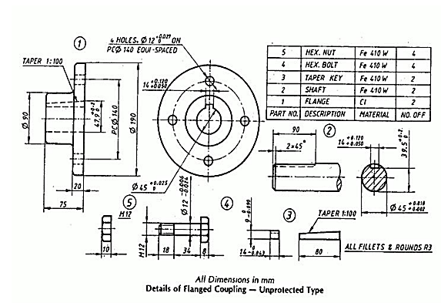

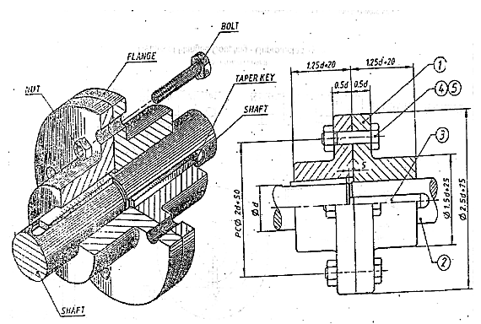

**Steps:**

1. Part drawings of flanges, nuts, keys, and bolts are created (as per given dimensions)

in Solid Works.

1. Parts are assembled using assembly features.
2. Finally, animation of the whole assembly is created using motion study features.
3. Create an exploded view of the complete assembly.